2018 ANNUAL REPORT ON THE ACTIVITIES OF THE INTERNATIONAL ACADEMY FOR SYSTEMS AND CYBERNETIC SCIENCES

Stuart A. Umpleby
President of the IASCYS Executive Committee
www.iascys.org
umpleby@gmail.com

Department of Management
George Washington University
Washington, DC 20052

November 12, 2018

Presented during a meeting of the European Union for Systemics
Brussels, Belgium
October 15-17, 2018

2018 ANNUAL REPORT ON THE ACTIVITIES OF THE INTERNATIONAL ACADEMY FOR SYSTEMS AND CYBERNETIC SCIENCES

Stuart A. Umpleby
President of the IASCYS Executive Committee

The fields of systems science and cybernetics were created to meet perceived needs. Ludwig von Bertalanffy said that over-specialization was a source of problems in modern society. He advocated General Systems Theory as a way of building bridges among specialists, without requiring them to abandon their specialties. Norbert Wiener said that the first industrial revolution substituted machines for human muscle power. The second industrial revolution would substitute machines for human intellectual tasks. This second industrial revolution is proceeding rapidly. Academic societies in many countries have been created to further develop these ideas.

The International Federation for Systems Research (IFSR) was created to assist the development of the fields of systems and cybernetics. Discussions at IFSR meetings revealed that scholars in systems and cybernetics were not being elected to their national academies of science. A solution would be to create an Academy for people who had made outstanding contributions to systems and cybernetics. The Academy was created as a branch of IFSR in 2010.

The founding meeting was held in Chengdu, China, in 2010. Those present included Matjaz Mulej, Jifa Gu, Gary Metcalf, Gerhard Chroust, Pierre Bricage, Gerhard Chroust, and Ranulph Glanville. A constitution and by-laws were written. The first group of academicians was selected. Pierre Bricage was chosen as Secretary General. In the first 9 years several meetings and workshops were held in seven countries.

Table 1. Meetings and Workshops
2010 Chengdu, China, 1st general assembly
2011 Brussels, Belgium
2012 Agadir, Morocco
2014 Vienna, Austria, 2nd general assembly
2014 Valencia, Spain
2015 Chengdu, China
2017 Chengdu, China
2018 Brussels, Belgium, 3rd general assembly
2019 Beijing, China

Table 2. Current Officers, the Executive Committee

Secretary General, Pierre Bricage, France
President, Stuart Umpleby, USA
Vice President, Ockie Bosch, Australia
Vice President, MatjazMulej, Slovenia
Vice President, Jifa Gu, China
Honorary Former President, Robert Trappl, Austria

Table 3. Regions of the World and Number of Academicians

East Asia 14
West Europe 28
East Europe and Russia 8
North America 8
Latin America 3
South Asia 0
Africa 0

Figure 1. Academicians by Country
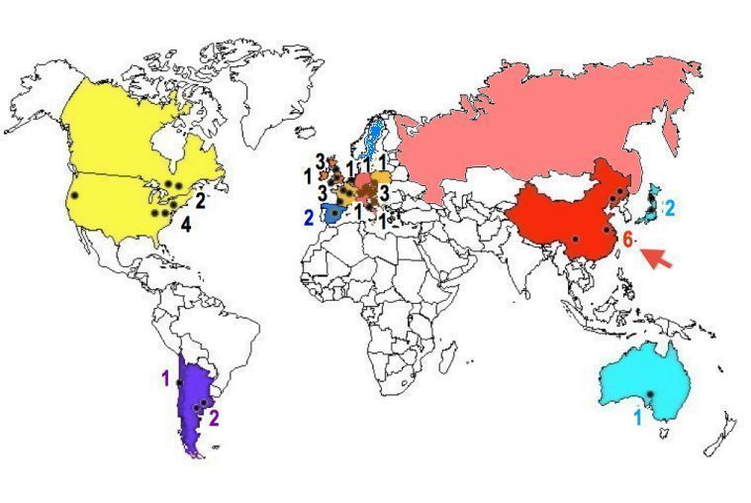

The academy accepts nominations from societies that are members of one of three federations
  - The International Federation for Systems Research (IFSR)
  - The World Organization for Systems and Cybernetics (WOSC)
  - The European Union for Systemics (EUS)
And from groups of three academicians.

Criteria for acceptance as an academician are the following:
Author of a renowned theory
Articles and books
Citations of writings
Organizer of conferences
Journal editorships
Teaching abroad or consulting
Practical applications
For further information see www.iascys.org.

Figure 2. 2015 Map of Activities
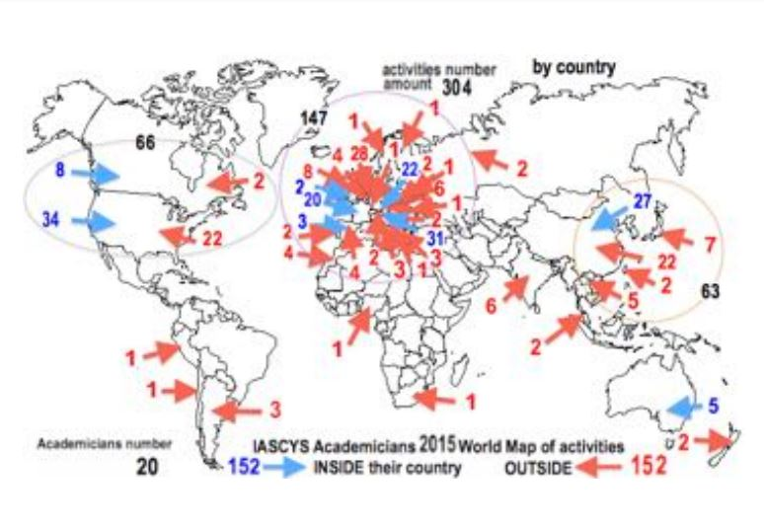

Figure 2 shows attendance at conferences. Blue means attendance at a conference in one’s own country. Red means attendance at a conference in another country. Most of the activity is in Europe. The Americas and Asia are also active regions. Currently there are no academicians from South Asia (e.g., India, Pakistan, Indonesia) or Africa.

Figure 3. Areas of Expertise

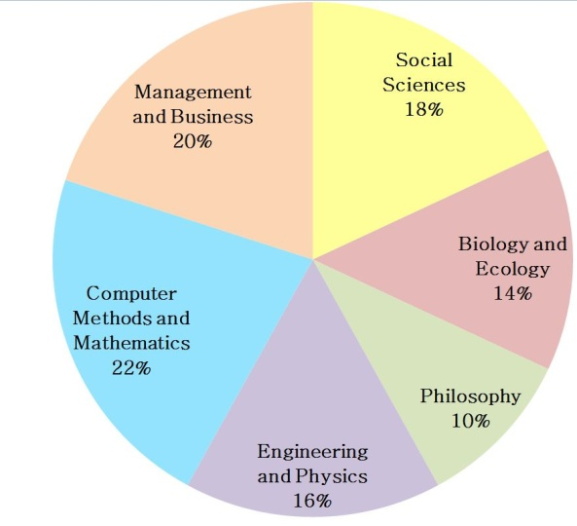

The areas of expertise of the academicians include management and business, social sciences, biology and ecology, philosophy, engineering and physics, and computer methods and mathematics.

Several positive trends support the survival and growth of the Academy. The International Council for Science has merged with the International Social Science Council to form the International Science Council, hence social science has been accepted within science. Continuing advances in communication and transportation aid diffusion of ideas and collaboration. Big data and data analytics provide new resources for research. Software advances such as Artificial Intelligence help to incorporate research results into decision-making. Handbooks and encyclopedias on systems and cybernetics are being prepared. The annual number of books on systems and cybernetics is increasing. See Figure 4.

Figure 4. Recent books about cybernetics

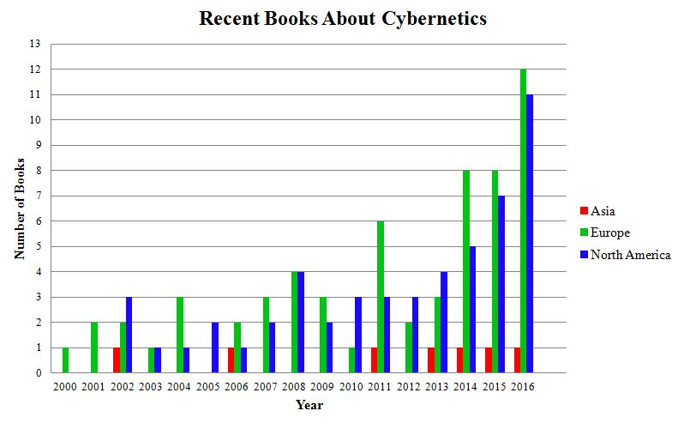

There are several future possibilities for the Academy. We may create on-line courses on systems and cybernetics. We may offer summer workshops on recent advances in systems and cybernetics. We shall post more definitions on Wikipedia and lectures on Youtube. We may make use of a computer conferencing system for use by academicians. There is interest in creating periodic reports on the state-of-the-art in subfields of systems and cybernetics

Additional tasks for members of the Academy would be
- Establishing more programs in systems and cybernetics in universities;
- Experimenting with John Warfield’s idea of a Horizons College in universities
  - Heritage College – the sciences, arts and humanities
  - Professional College – business, law, engineering, medicine, architecture, agriculture
  - Horizons College – multi-disciplinary, problem-oriented, client-based;
- Advocating Ranulph Glanville’s suggestion to make systems and cybernetics the core curriculum of design schools.

To our academicians we ask that you send nominations of people whom you think should be academicians; help us improve our use of computer conferencing and the web both internally and for outreach; work on projects with Academy members, for example write summaries of advances in a subfield, such as system dynamics or agent-based modeling or action research; work on fund raising.

