A QUALITY IMPROVEMENT APPROACH TO ASSESSING
AN ORGANIZATION’S CLIMATE FOR CREATIVITY AND INNOVATION

Igor Dubina and Stuart Umpleby

The George Washington University,
2033 K Street NW, Suite 230, Washington, DC 20052
igor_dubina@yahoo.com, umpleby@gmail.com

December 30, 2010

Prepared for the 17th Annual International Deming Research Seminar
Fordham University, New York City
21-22 March 2011

A QUALITY IMPROVEMENT APPROACH TO ASSESSING
AN ORGANIZATION’S CLIMATE FOR CREATIVITY AND INNOVATION

Igor Dubina and Stuart Umpleby

The George Washington University,
2033 K Street NW, Suite 230, Washington, DC 20052
igor_dubina@yahoo.com, umpleby@gmail.com

Abstract This paper discusses a new approach to assessing organizational climate. The approach is based on the QIPM (Quality Improvement Priority Matrix) method for collecting and processing data. QIPM is a general improvement tool to identify priorities and observe whether actions lead to noticeable results. The authors describe how this tool can help in finding an optimal sequence of steps to improving the work environment for creativity and innovation.

Introduction
Altering a company’s workplace environment is the most direct way to develop and manage employees’ creativity. Improving the organizational climate for creativity and innovation can effectively promote problem solving in a company and thereby increase its productivity and competitiveness.

Approaches to improving an organization’s creative climate have been widely discussed in the recent literature (Amabile, 1996; Anderson, 1996; Dubina, 2006a, 2007; Ekvall, 1996; Hunter, et al., 2005; Isaksen, et al., 1999; Martins, and Terblanche, 2003; Mathisen and Einarsen, 2004). The creative environment depends on many factors, such as management structure, leadership style, workplace conditions, socio-psychological atmosphere, available resources, motivation and reward system, etc. The concept of optimizing creativity management (Dubina, 2006b, 2007, 2009) assumes that interventions for improving the environment for organizational creativity and innovation are directed to the most needed areas and in the most appropriate amounts. So, optimally managing creativity requires the constant monitoring of organizational climate and improvement efforts. Therefore, assessment methods and instruments to evaluate improvement efforts are required.

Measuring an organization’s climate for creativity and innovation can help in identifying necessary actions for improving the climate. The measurement of the climate characteristics can help to answer the following questions: How well does the climate fit the tasks or purposes of the organization? How supportive is the work environment for employee creativity? What structures may help in promoting employee creativity and better match the needs of the organization? Assessing the work environment helps in directing actions to improve organizational performance. Thus, assessing the organizational climate to achieve the maximum effectiveness can be considered one of the key elements of creativity and innovation management.

Existing Approaches to Work Environment Assessment

A number of approaches to the assessment of the work environment for creativity and innovation have been developed recently. Reviews of the literature (Hunter, et al., 2005) reveal that there are more than 40 different conceptions of creative climate and, correspondingly, ways of assessing it. According to the survey of Mathisen and Einarsen (2004), the best known and most used instruments are:
- Assessing the Climate for Creativity (KEYS), originally called the Work Environment Survey, developed by T. Amabile and specialists from the Center for Creative Leadership (Amabile, et al., 1999);
- Creative Climate Questionnaire (CCQ), originally called the Climate for Innovation Questionnaire, developed by G. Ekvall (1996);
- Situational Outlook Questionnaire (SOQ) (Isaksen, et al., 1999);
- Team Climate Inventory (TCI) (Anderson and West, 1996).
These instruments are well described and analysed in the literature. They may be very helpful for managers and consultants in assessing the effect of creative climate improvement efforts and in identifying relative strengths and weaknesses within and between work groups. The advantages of the use of the existing instruments are considerable. They are well-tested and reliable. There are a great number of published studies carried out with them and available data, which can be compared with newly acquired data.

However, there can be some problems with using such instruments. All of the existing instruments are based on a set of questions (usually, 50 – 150 items) and the categories (or factors) of an organizational climate are evaluated on the basis of replies to these questions. The questionnaires often take considerable time to complete. Usually, it also takes much time to analyse data, while sometimes we need just a quick evaluation of a climate. Finally, it is not so easy to modify an existing instrument to use in another cultural context. The development of the Situational Outlook Questionnaire (SOQ) (Isaksen, et al., 1999) is an example. It is an English version of the Creative Climate Questionnaire (CCQ) (Ekvall, 1996), and it is based on the same climate model and consists of as many items as the CCQ. But actually they are different instruments, since a “direct” and literal translation is impossible because of linguistic and cultural realities. The translation of questionnaire items results in a new instrument. According to the theory of measurement, changing any item of a questionnaire may change the indexes of measurement reliability and validity. Therefore, multi-fold testing is required for a “translated” measurement instrument. All of these factors were a rationale to develop a simpler instrument which can be based on direct evaluation of climate categories. Such an instrument was developed using a QIPM approach.

A QIPM Approach to Work Environment Assessment

A Quality Improvement Priority Matrix (QIPM) is a relatively simple method for collecting and processing data for decision-making. A QIPM questionnaire asks employees to rate several features of an organization on two scales – Importance and Performance. That is, how important is that particular feature, and how effectively is the organization currently performing on that feature. A QIPM is usually used in determining priorities and for monitoring performance improvement (Dubina and Umpleby, 2006).

We use a QIPM approach to evaluate the key factors that contribute to the generation of new ideas and their successful implementation as projects in organizations. In spite of a wide variety of organizational characteristics used in the existing instruments, it is possible to specify several major factors, such as Challenge, Freedom, Idea Support, Leadership, Trust, Openness, Work Group Support, etc. Our model of Organizational Climate for Creativity and Innovation (OCCI) includes 4 main categories and 17 factors (Dubina, 2009):
1. Conditions for creative initiatives
1.1. Safety and guaranties
1.2. Risk-tolerance
1.3. Freedom / Autonomy in decision-making
1.4. Resources
1.5. Workload pressure / Idea-time
1.6. Challenging work
2. Creative cooperation / Team work
2.1. Organization for creative team work
2.2. Team’s openness for new ideas
2.3. Effectiveness of team work
2.4. Psychological atmosphere in workgroup
3. Management and organizational support for creative initiatives
3.1. Idea collection
3.2. Idea orientation (whether management encourages ideas directed to current problem-solving or developing new opportunities for business)
3.3. Idea acceptance
3.4. Idea support
3.5. Idea reward
4. Creative ideas implementation
4.1. Organizational openness to change / Dynamism
4.2. Innovation effectiveness

To evaluate these 17 factors with a QIPM-type method, we developed a questionnaire including the 17 corresponding items:
- Safety for suggesting new ideas
- Supervisory tolerance for risk and uncertainty
- Employees’ freedom / autonomy in decision-making
- Sufficient resources provided for elaborating new projects
- Sufficient time provided for employees’ work on new projects
- Challenging work
- Supervisory encouragement to work cooperatively on new projects
- Organizational openness to new ideas
- Effectiveness of team work
- Trust in the workgroup
- An effective system for recognizing new ideas in an organization
- Producing new ideas for trying new opportunities for business, not only for current product development
- Supervisory positive acceptance of employees’ creative suggestions
- Supervisory encouragement of employees’ creative approach to doing work
- Fair rewards for creative suggestions
- Dynamism of an organization and its openness to changes
- Effectiveness of creativity and innovation activities

According to the general QIPM approach, respondents should evaluate these factors with two 5 point scales: Importance scale (from 1 that is unimportant to 5 that is extremely important) and Performance scale (from 1 that is very poor to 5 that is excellent). The averaged estimates for each factor are used as coordinates in a diagram with the Importance – Performance axes and 4 quadrants (Improvement Priority Matrix) (Fig.1).

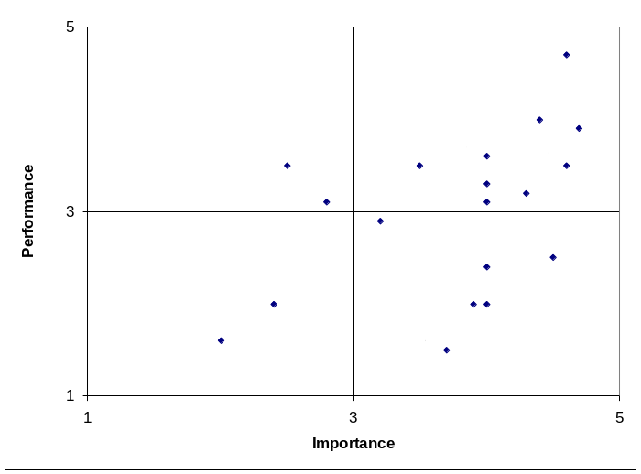
Figure 1. Estimates for climate factors in Improvement Priority Matrix

The factors of greatest interest for improvement are those that fall in the South-East quadrant defined by high importance and low performance. Those climate factors are considered the highest priority elements for an organization and need to be improved most of all. A ratio of Importance to Performance (IPR) was also calculated to increase the accuracy of climate assessment: IPR = I / Р. The higher the IPR, the higher the priority a factor has.

An obvious advantage of this approach to climate assessment is making allowance for the importance (or “weight”) of each climate factor for an organization. Traditional approaches usually do not take item or factor “weights” into account. The method is rather easy for respondents to understand. Applying this approach, it is possible to very quickly (up to 7-10 min) assess an organizational climate and get a clear “snapshot” of it.

A Software Module

A number of software instruments are based on the QIPM technique (see, for instance, www.qipm.com). However, the analytical tools for processing data and visualizing results are rather limited there. The authors of this paper also developed a software product for the diagnostics and support of organizational creativity and innovation. In this software, there is a special module which realizes the approach described here to climate assessment based on the QIPM method.

This software provides many options for statistical analysis and for visualizing results. In particular, it is possible to make a sample for analysis from raw data based on criteria such as employee status, gender, seniority, education, etc. Such analyses are useful to understand how the work environment influences different groups of employees. It is also possible to visualize the employees’ responses to questionnaires to exclude some “noise” responses. The software converts raw data into a standardized scale, calculates all basic statistical indexes, including means, standard deviation, standard errors, and confidence intervals. The results can be visualized in many ways. For example, data can be represented in a QIPM matrix (Fig. 2). Such indicators as Importance, Performance and Importance-Performance Ratio can be also represented with different diagrams and graphs (Fig. 3 - 5). A visual and interactive editor added in the software helps to change a set of questions and the format of data visualization.

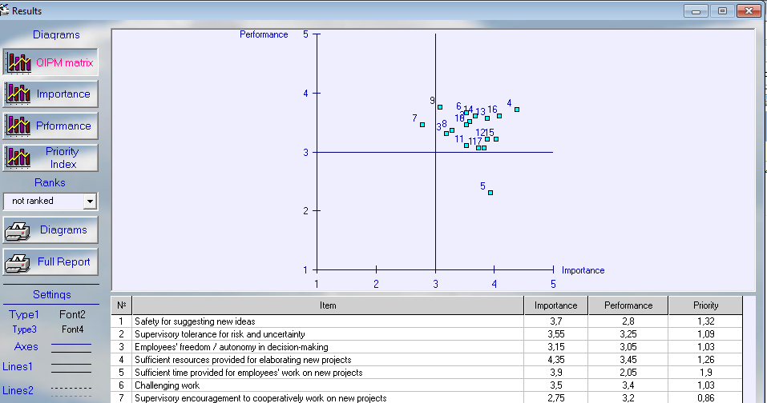
Figure 2. An example of QIPM and means for the climate factors
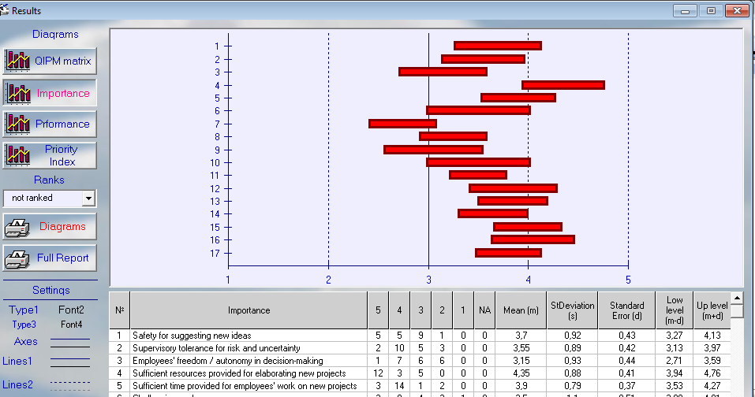
Figure 3. An example of visualization and descriptive statistics for the Importance index

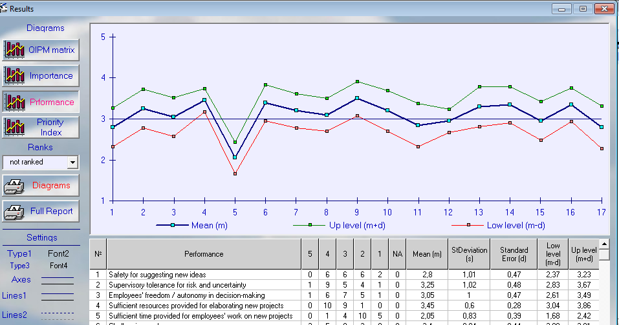
Figure 4. An example of visualization and descriptive statistics for the Performance index

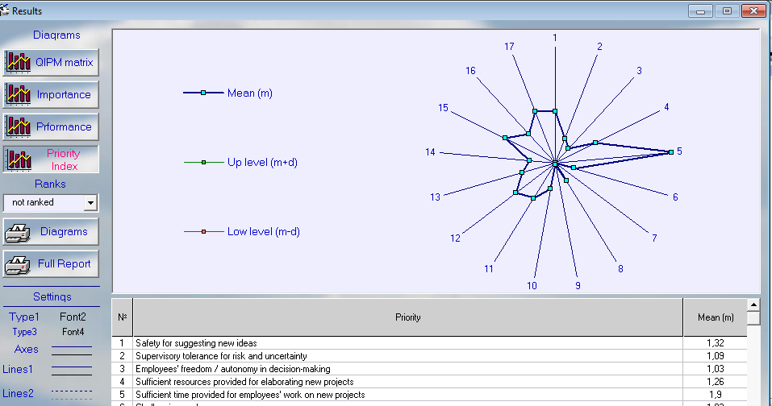
Figure 5. An example of visualization and descriptive statistics for Importance-Performance Ratio

Conclusion

This method may be used independently or in a complementary way for assessing climate with the existing approaches in order to gain additional information about the work environment for creativity and innovation. The measurement instrument is simple, and it helps in finding an optimal sequence of steps to improve the work environment for creativity and innovation. Repeated use of this method, about every 6 months or a year, can provide an optimal strategy for managing employees’ creativity more systematically, methodically, and relevantly to the specificity of an organization, its goals, and resources. However, this approach to climate assessment needs additional examination to soundly establish its validity and reliability. The software module can be improved by extending it to a client-server technology application and including in it a tool to analyze the dynamics of the main indexes (Importance, Performance, and Importance-Performance Ratio) over time. This application of a QIPM approach focuses primarily on creativity and innovation in an organization. However, the range of QIPM applications can be much wider. QIPM is a general improvement tool to identify priorities and observe whether actions lead to noticeable results. The climate for creativity and innovation is just one area for improvement. A similar improvement analysis could be conducted, for example, in terms of benefits and costs. The developed software can be easily modified for required principal “axes” and the set of factors to be analyzed.

Acknowledgment Part of the research for this paper was supported by the Fulbright Program, which is funded by the Bureau of Educational and Cultural Affairs (ECA) of the U.S. Department of State and administered by the Council for International Exchange of Scholars (CIES). The opinions expressed herein are the authors’ own and do not necessarily represent the views of either the ECA or the CIES.

References

Amabile, T.M. (1996) Creativity in Context: Update to the Social Psychology of Creativity, Oxford, MA: Westview Press.
Amabile, T. M., Burnside, R. M. and Gryskiewicz, S. S. (1999). User’s manual for assessing the climate for creativity. Greensboro, NC: Center for Creative Leadership.
Anderson, N. R. and West, M. A. (1996) “The team climate inventory: development of the TCI and its applications in teambuilding for innovativeness”, European Journal of Work and Organizational Psychology, No. 5, pp. 53-66.
Dubina, I.N. (2006a) “Measurements in creativity management: why and how to measure intangibles”, Int. Journal of Knowledge, Culture and Change Management, Vol. 6, No. 6, pp. 149-155.
Dubina I.N. (2006b) “Optimizing creativity management: problems and principles”, Int. Journal of Management and Decision Making, Vol. 7, No. 6, pp. 677-691.
Dubina, I.N. (2007) “Optimally managing creativity in organizations”, in Carayannis, E.G. and Chanaron, J.J. (Eds.) Managing Creative and Innovative People: The Art, Science and Craft of Fostering Creativity, Triggering Invention and Catalyzing Innovation. Westport, CT: Praeger, pp. 143-169.
Dubina, I.N. (2009) Creativity Management in Innovation Economy, Moscow: Academia (in Russian).
Dubina, I.N. and Umpleby, S.A. (2006) “Agenda setting and improvement monitoring in a university department”, in The Proceedings of the 12th Annual International Deming Research Seminar, New York, pp. 18-28.
Ekvall, G. (1996 ) “Organizational climate for creativity and innovation”, European Journal of Work and Organizational Psychology, Vol. 5, pp.105–123.
Ekvall, G. (1999). “Creative climate”, in Runco, M. A. and Pritzker, S. R. (Eds.) Encyclopedia of Creativity, San Diego: Academic Press, pp. 403-412.
Hunter, K. Bedel, L. and Mumford, M. (2005) “Dimensions of creative climate: a general taxonomy”, The Korean Journal of Thinking and Problem Solving, Vol. 15, No. 2, pp. 97-116.
Isaksen, S. G., Lauer, K. J., and Ekvall, G. (1999) “Situational outlook questionnaire: a measure of the climate for creativity and change”, Psychological Reports, No. 85, pp. 665-674.
Martins, E.C., and Terblanche, F. (2003) “Building organizational culture that stimulates creativity and innovation”, European Journal of Innovation Management, Vol. 6, No. 1, pp.64-74.
Mathisen, G.R. and Einarsen, S. (2004) “A review of instruments assessing creative and innovative environments within organizations”, Creativity Research Journal, Vol. 16, No. 1, pp.119-140.

