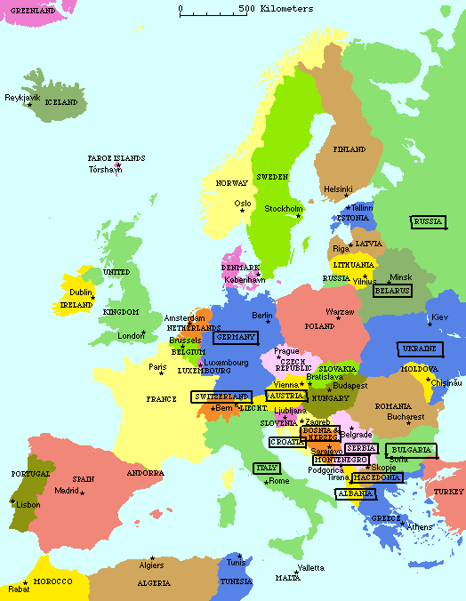

[**RUSSIA**](http://blogs.gwu.edu/umpleby/russia-2/)