Classification of Carbon Nanoparticle Inks for Inkjet Printing Applications
Zachary McNulty¹ Nathalya Ramirez² Michael Orrill³ Dr. Saniya LeBlanc⁴
according to the names of department and institutions (10pt)
Corresponding Author’s name should be additionally marked with an asterisk ^{1*} and its e-mail account should be included. (10pt)

Introduction
Due to its ability to print many different materials, inkjet printing is a valuable fabrication technique in the field of technology today. With the ability for a user to create their own ink, prototyping can be quickly and cheaply achieved by simply loading a substrate and patterning. Inkjet printing is already widely used for creating experimental printed circuits as it is both cheaper and quicker to print a prototype PCB with a silver or gold-based ink than to order a traditional silicon-based one [1], [2].

Motivation
As global warming continues, there is a demand for a carbon neutral source of inkjet ink. Biochar is an organic charcoal-like material created by heating agricultural waste without access to oxygen [3], and is already used in the treatment of soil, filtering water and air, biofuel production, carbon collection and more. By creating Hollow Carbon Nanospheres (HCNS) from biochar, and suspending them in liquid, one can create a carbon negative inkjet ink.
Carbon materials have showed promise in the field of printing, and have been demonstrated in the creation of electrodes, antennas, and capacitors [4]. Depending on the properties of the biochar used in synthesis allows for possible variation in the resistivity of the ink, as amorphous biochar HCNS could potentially be used for resistors and sensors, while conductive HCNS could be used for electrodes and capacitors. Currently, carbon nanotubes are widely being used in inkjet printing applications, while HCNS are mostly use for biological applications like drug delivery.
Before features can be printed using HCNS, a proper ink has to be created. The purpose of this experiment is to classify the physical properties of HCNS in dispersions. Concentration of particles, zeta potential of dispersions, viscosity of dispersions, and particle density of printed ink was collected. The purpose of taking these measurements is so that more stable and more concentrated inks can be fabricated in later batches using these measurements.

Approach/ research Methods

Approach
First, three dispersions of varying concentrations were created. The base of the inks created is a varying mixture of ethylene glycol and water, as they are commonly used bases for inkjet printing dispersions due to their surface energies and viscosities being close to the ideal values for an inkjet printer. The ratio of water to ethylene glycol to water was varied slightly in the three batches, while excess HNCS was added to each solution, to allow each solution to become completely saturated with nanospheres.
Different concentrations of ink were created so that differences in the concentrations of nanoparticles and physical properties could be observed, while keeping the properties necessary for printing controlled and so that printed ink could be observed without accounting for difficulties getting the HCNS particles onto the medium. Due to shortages of the HNCS material, only three concentrations or ink could be fabricated. In the interest of the ink’s usability as a printable deposition technique, the particle density of printed ink was also measured, varying both the recipe for the disperse medium and the amount of layers printed on the substrate.

Research Methods
Dispersions were created using an ultrasonicator and a centrifuge. First, three recipes for three different concentrations were created, controlling for viscosity as to keep it in the printable range. These inks were created by first measuring the correct amount of ethylene glycol and water, then adding .1g of HCNS, effectively saturating the solution. The nanospheres were first dispersed by placing it on a magnetic stirrer until the HCNS appeared evenly mixed. The dispersion was then placed in an ultrasonicator to ensure that the HCNS was unable to conglomerate in the mixture. In order to avoid bringing the dispersion to its boiling point in the sonicator, the ink was placed in an ice bath and the sonicator was placed on a 50% duty cycle. Care was exercised as to not let the sonicator come into contact with the glass beakers used to hold the mixture and ice bath, as this could damage them.
Excess carbon was removed using a centrifuge, and cleaned out of any containers using IPA. The IPA was then boiled off, and the excess carbon was used to calculate the experimental concentration of the solutions. The dispersion was allowed to sit overnight in its container to allow for the dispersion to settle and any extra carbon that was not separated in the centrifuge to sediment.
To measure the viscosity of the dispersions, a rheometer with a 1° cone was used. In order to prevent the ethylene glycol from absorbing any ambient moisture, a solvent trap was placed on the rheometer, isolating the dispersion. With the viscosity recorded, the dispersions underwent DLS analysis in a Zetasizer Nano to measure their zeta potential and size distribution to ensure that the HCNS would not sediment or conglomerate together in the mixture, forming globules that could clog an inkjet nozzle.
The ink’s viability as a printable substance was tested using a DOD inkjet printer. The ink was loaded into a printer cartridge and calibrated, starting with a preset made for pure ethylene glycol and calibrated to ensure the best results. Only two of the three inks created were suitable as a printing medium (ADD WHY WHEN YOU SEE MICHAEL). The two inks were printed on glass microscope slides. The pattern used was six lines of varying thickness in layers, ranging from ten to sixty layers of printed ink. In order to ensure that each layer was dry before the next layer was printed on top of it, the substrate was heated to 40°C and the substrate was allowed to rest one minute between layers.
The ink was imaged using an optical microscope with an attached camera. Both bright field and dark field images were taken of each printed line. From the dark field images, the particle density was measured using ImageJ. This was done by cropping the image of the printed slides to a predetermined square having an area of 75μm by 75μm. The accuracy of this calculation was verified using a test slide containing a printed dot of a known size.

Results

Fig. 1. Particle count as a function of layers printed

Both samples printed appear to reach a critical point at around 40 layers, where the particle density starts to go down as more layers are applied. This is likely due to the ink not being allowed to fully dry between the application of layers. As a result, the ethylene glycol mixture builds up on the glass slide, and eventually begins to expand. This creates a wider and less uniform line with wide “bubbles”, and more area for the carbon nanoparticles to occupy.

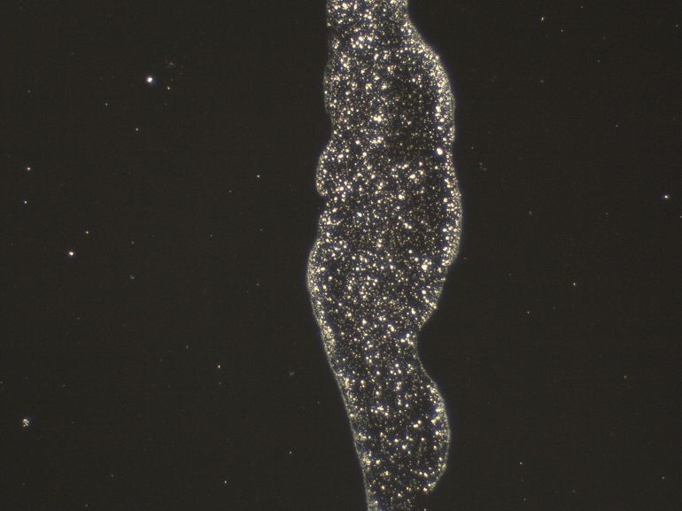
Fig. 2. Line irregularity occurring at 60 layers of printed ink

This bubbling effect can be reduced by allowing more time for the ink to dry between coats and raising the temperature of the substrate, to facilitate the evaporation of the disperse medium. This would not be a problem once an ink with sufficient saturation of HNCS is created, as creating a feature of any size could be achieved in just a few coats, as opposed to forty.
Lines printed with sample 1’s ink all appear to be more concentrated than the lines produce from sample 2’s ink. This is likely due to sample 1’s higher concentration of carbon nanospheres. Optimizing the saturation of these particles would allow for a much more concentrated dispersion capable of carrying much more carbon without sedimenting it. This can be done by raising the ph of the dispersion, or by varying the materials used to produce a higher zeta potential while keeping a similar viscosity and surface area.

References
- Arrese, J. "Flexible Hybrid Circuit Fully Inkjet-Printed: Surface Mount Devices Assembled by Silver Nanoparticles-Based Inkjet Ink." Journal of Applied Physics 121.10 (2017): 104904; 104904. Print.
- Byon, Hye H. "Thin Films of Carbon Nanotubes and Chemically Reduced Graphenes for Electrochemical Micro-Capacitors." Carbon (New York) 49.2 (2011): 467; 467. Print.
- Kaal, Joeri J. "Molecular Characterization of Ulex Europaeus Biochar obtained from Laboratory Heat Treatment Experiments – A pyrolysis–GC/MS Study." Journal of Analytical and Applied Pyrolysis 95 (2012): 212; 212. Print.
- Song, Hae, et al. "Preparation of Aqueous Ag Ink with Long-Term Dispersion Stability and its Inkjet Printing for Fabricating Conductive Tracks on a Polyimide Film." Journal of Applied Physics 108.10 (2010): 5. CrossRef. Web.

