Energy Materials Analysis for Additive Manufacturing by Selective Laser Melting
Rachel Gray^{2,3}, Devin Jessup^{1,3}, Dr. Saniya LeBlanc^{2,3}
¹Department of Electrical & Computer Engineering
²Department of Mechanical & Aerospace Engineering
³The George Washington University

Introduction
Thermoelectric generators are devices which aid in the capture and reuse of waste heat from various applications, such as factories and power plants, consumer products such as cars. These devices work via a process called the Seebeck effect, wherein a temperature difference produced in the thermoelectric generator propagates a voltage difference. This voltage difference may be harvested via electric circuits and converted into useable energy. Currently, thermoelectric generators are limited by their basic geometries. To combat this, the selective laser melting (SLM) manufacturing process could be used in combination with semi-conductive powders in order to produce more complex shapes. However, there is not currently a significant amount of research done on semi-conductive powders for use in SLM, and there are particular properties which make these powders difficult to use in the process. Powder morphology is a significant barrier that must be overcome before semi-conductive powders may be used widely in SLM; particularly, the sizes of these powders and the shape of the particles must be considered and controlled for. Therefore, this research was primarily concerned with examining bismuth telluride’s powder morphology and how that informs its usefulness in the SLM manufacturing process.
Such research is relevant because the SLM process requires powders with a specific morphology profile. Generally, powders will need a high degree of circularity, as well as a narrow particle size distribution, for adequate flowability. The flowability of a powder helps in producing an even sintering across the powder bed. However, with a narrow particle size distribution, the resulting solid is less dense and more prone to breaking along internal faults. Additionally, the convexity of a powder should be low so as to reduce inter-particle friction. Therefore, with these considerations in mind, it is necessary to characterize bismuth telluride before use, in order to determine its potential effectiveness. As sieves are used in portioning out different particle size ranges, one must characterize the effectiveness of that process as well. To produce thermoelectric generators using semi-conductive powders with appropriate densities and no faults, a profile of bismuth telluride must be developed.

Methods

Imaging
In order to characterize the powders, light microscopy was used to produce images. A 20X magnification was found to be most effective in balancing the glare against particles with appropriate focus of both large and small particles. To mount the powders on the slides for imaging, 30.0 mL of ethylene glycol was used with 0.25 grams of bismuth telluride. This suspension was then spin coated onto glass

slides at different speeds for various times, as shown in chart 1. (insert chart with spin speeds/times/accel. for each trial). Four trials were determined to be acceptable for analysis.

Trial | RPM | time (s) | acceleration
t1
T2
t3
t4

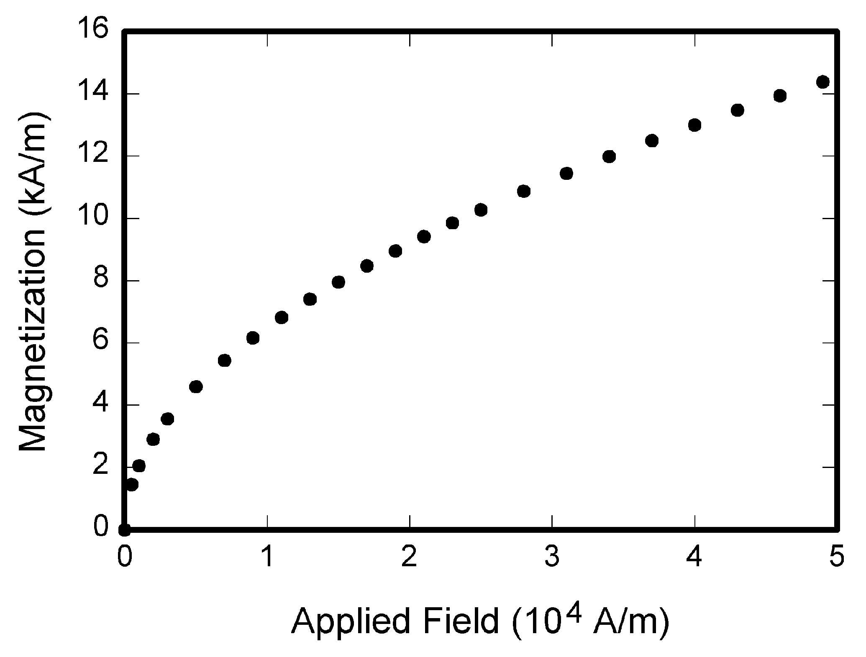

Program
Once the images were acquired, they were all processed through an ImageJ software derivative called Fiji Is Just ImageJ (FIJI). In the program, each image was converted to 8-bit greyscale and then its contrast was enhanced. Following this, a mask was applied over the image, inverting the look up table (LUT) and producing a flat black and white image. Additionally, scale was applied to each image in microns. Utilizing the black and white image, the particles were then analyzed to obtain values for area, perimeter, Feret’s diameter, and convex hull perimeter. To obtain the convex hull perimeter, a plugin was applied to FIJI called “Shape Filter” [1]. A macro was utilized to automatize the process and to help control for human error. An area threshold of 30 um was established for each image, in order to remove particles which would be too small for effective use in SLM and which would interfere with program analysis methods.

Analysis
MATLab software was used to graph and interpret the data gathered through FIJI.

Results
During the course of the investigation, it became evident that the sieving process was inaccurate. All of the sieved particle batches contained a great number of particles which were well outside the determined range for that batch. Additionally, it became obvious that the bismuth telluride tended to be less circular in shape and more polygonal, as evidenced by low circularity values. Finally, the convexity of the particles also tended to be low, suggesting largely irregular surface areas.

Caption caption caption

Fig. 1. Magnetization as a function of applied field

Conclusion
Due to the inaccuracy of the sieving process and the importance of appropriately sieving the powder, it would be necessary to establish an improved method. A precise combination of mesh sizes would likely improve the final output which would go into the powder bed; to determine this output, calculations could be made based on Spierings’ requirements [2]. These calculations represent the ratio of D₉₀ and D₁₀ particles (2), as well as specify the relation between the t_{eff}, or effective powder layer thickness, and the D₁₀ particles (1). Using these ratios, a suitable distribution of large and small particles could be acquired which would provide the greatest solid density while retaining flowability and other necessary powder bed qualities.
$\frac{t_{eff}}{D_{90}}≈1.5$ (1)
$\frac{D_{90}}{D_{10}}≈5$ (2)

Additionally, due to the low circularity and convexity values, there would need to be a certain amount of particle preprocessing before use with SLM. To prepare the semi-conductive powders, some process would need to be applied to bring convexity values closer to 1. The result of this would be reduced inter-particle friction, promoting better flowability across the powder bed. Further research would be necessary to test whether this would be effective.

Acknowledgements
The researchers would like to thank Haidong Zhang and Michael Orrill for their expertise and help throughout the project. Additional thanks go to the National Science Foundation for enabling the Nanotechnology Fellow’s Program with Award EEC-1446001.

References
- Wagner, T and Lipinski, H 2013. IJBlob: An ImageJ Library for Connected Component Analysis and Shape Analysis. Journal of Open Research Software 1(1):e6, DOI: http://dx.doi.org/10.5334/jors.ae
- A.B. Spierings, and G. Levy, "Comparison of density of stainless steel 316L parts produced with selective laser melting using different powder grades," in Solid Freeform Fabrication Symposium, Austin, TX, 2009, pp. 1-12.

