High Contrast Gratings for Guiding Light
Christopher Long^{1,4,+}, Brenna Calhoun^{2,4,+,*}, Mohammad Tahersima^{1,4}, Dr. Saniya LeBlanc^{3,4}, Dr. Volker Sorger^{1,4}
1 Department of Electrical and Computer Engineering 2 Department of Biomedical Engineering 3 Department of Mechanical and Aerospace Engineering 4 George Washington University + Joint Author
*Corresponding Author bcalhoun@gwu.edu

Introduction

Objective
High Contrast Gratings (HCGs) are nanostructures used in optical engineering as light guiding architectures. These gratings, fabricated at the micro and nanoscale, are being researched for use in the solar industry as a method to guide light directly into photovoltaic cells. The gratings, developed using technology in GW’s Nanofabrication and Imaging Center, can be designed to guide specific wavelengths of light from the solar spectrum. This project was an attempt to develop multiple HCGs designed with different parameters to test the wavelengths that are most efficiently guided.

Motivation
Light-guiding architectures have been investigated and tested for the use of guiding light for several applications. HCGs in particular have been demonstrated to function as a focusing reflector as well as Vertical-Cavity Surface-Emitting Lasers [1]. One of the main focuses in the development of light-guiding architectures is in the solar industry.
As the world moves towards using more solar energy, methods are being developed to optimize and create more efficient solar cells. The current methods of producing multi-junction solar cells are complex and costly to produce in large quantities. With HCGs and light-guiding architecture, the focus of solar energy can move from costly and complex photovoltaic cells to producing more cost-effective light guiding structures. These structures will harness a certain range of wavelengths of the solar spectrum and guide photons towards the photovoltaic cell. This allows for allocation of resources towards less costly materials for HCGs instead of materials for photovoltaic cells.

Methods and Approach

Approach
One of the limiting factors in solar cell performance is carrier thermalization. This occurs when the light that is exposed to the semiconductor material has a photon energy that is higher than the material’s band gap energy. This energy would create a photovoltage which would have a resulting energy that is lost to heat. When the light has a photon energy that is below the material’s band gap, it does not get absorbed. A solution to this was the introduction of multi-junction solar cells whose architecture would include layers made of different semiconductor materials that would each have a band gap that would correspond to different ranges of wavelengths on the solar spectrum. This would more efficiently reduce the amount

of energy lost to heat or not absorbed by the material. However, the design of these solar cells is complex and expensive to fabricate and the device performance is limited due to the necessary current matching of the layers.
An approach to this issue is the use of light guiding architectures for spectral splitting [2]. The structure would direct light of different wavelengths to individual solar cells that would have matching band gaps to the corresponding wavelengths. This would allow a minimization of the energy lost to heat and energy not being absorbed at all since there would be full flexibility in the choice of semiconductor material for the different solar cells in order to efficiently match the wavelengths of light directed to it. The development of HCGs would work to resolve these issues using specific spectral splitting. Silicon, for example, has a energy bandgap of 1.18 eV [3] which corresponds to a wavelength of light of 1130 nm so the HCGs would aim to guide light of 1130 nm from the solar spectrum. They would have parameters that are designed to guide a certain range of wavelengths that would be optimal for a certain semiconductor bandgap.

Methods
In order to estimate the parameters of the grating designs, a finite-difference time-domain (FDTD) analysis was conducted. Reflectance, transmittance, and guiding efficiency of the grating structure were calculated for a 1D diffraction grating made up of a wafer of 220 nm of S i₃N₄, 2 μm of SiO₂, and 500 μm of Si. To do this, the Lumerical FDTD solver was used for all Maxwell equation calculations. We launched a planewave source with a 30 degrees angle to the surface of the diffraction grating. Four monitors were positioned on four sides of the structure, surrounding the device, to measure the transmission of EM waves for each side. The power flow analysis measures the net transmitted power. For simplicity, we sweep the grating pitch while keeping the fill factor to 50%. To ensure that scattered light does not return to the simulation region a Perfect Matching Layer (PML) was applied as boundary condition in all six directions. The analysis is shown in Fig. 1 which shows that the Si₃N₄ grating of 220 etch depth, a 760 nm pitch, and a 0.5 fill factor can achieve efficient coupling for a 640 nm bandgap. This analysis provided values of HCGs pitches that best guide specific wavelengths of the solar spectrum.
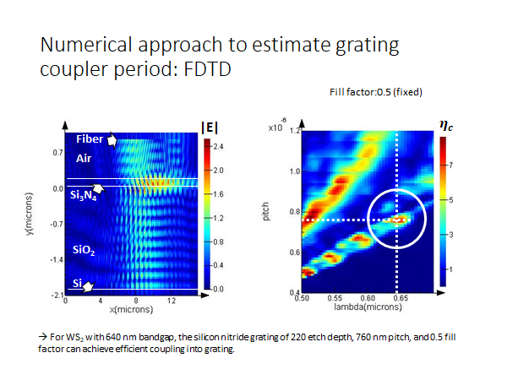
Fig. 1. FDTD Analysis of Si₃N₄ Gratings

To fabricate and image the HCGs, nanofabrication techniques were used in the Science and Engineering Hall’s Nanotechnology and Imaging Center at The George Washington University (GWU). A sweep of eleven gratings with pitches ranging from 300-1300 nm in increments of 100 nm were chosen for the design. The gratings would be made out of a 220 nm thick Si₃N₄ wafer with a length of 200 μm, and the width to be half of the pitch i.e. a grating with a 300 nm pitch would have a width of 150 nm. The HCGs were designed using the RaithCAD software with a dose factor of 3. The Si₃N₄ wafer was prepared using PMMA as the photoresist, spun at 4000 rpm for 45 sec, and baked on a hot plate for 2 min at 180ºC. Soon after, the HCGs were fabricated using Electron Beam Lithography (EBL) which was done in the Raith PIONEER tool. The sample was then developed using a PMMA developer that is MIBK:IPA 1:3 for 3 min and then cleaned in IPA for 1 min. The sample was then taken to the National Institute of Standards and Technology for dry etching using the OXFORD Plasmalab system 100.
Once the gratings were successfully fabricated out of Si₃N₄, they were imaged using an optical microscope and a Focused Ion Beam using FEI Helios FIB SEM. The HCGs were then tested using a free space optical set-up in GWU’s Photonics lab. Each grating was exposed to a broad band, collimated, white light beam for one second. This exposure was repeated on two points on the gratings. Using an Andor Solis spectrometer, the irradiance of each wavelength reflected off the grating was measured through a beam splitter that scattered light lower than 500 nm. This measurement was important for indicating that the gratings are guiding specific wavelengths of light depending on their structure and pitch specifications.

Results
The data collected by the spectrometer showed a plot of the wavelength of the light incident to the grating versus the irradiance of the reflected light on the grating. A MATLAB code was written to average the multiple results from each grating and then graphed. This was then compared to an exposure of the beam to a point off the grating but on the Si₃N₄ wafer. The difference in these sets of data were calculated to see if the gratings would guide a more narrow range of wavelengths than the Si₃N₄ wafer. By taking the difference between the tests that were on the grating and the tests that were on the wafer, the graph shows the irradiance of the light that is being guided by the HCGs instead of the irradiance of the reflected light. The graphs of gratings with a 300 nm pitch, a 700 nm pitch, and 1300 nm pitch are shown in Fig 2 with arrows pointing at the maxima of irradiance. The maxima of these graphs indicate the wavelength of light which was presumably the most efficiently guided by the gratings. The maxima and the corresponding wavelengths are shown in Table I. The table allowed us to see what pitch of the Si₃N₄ HCGs would allow for the guiding of the specified wavelength. The limitation of the testing equipment did not allow for testing of the direction of the light that was guided by the gratings.
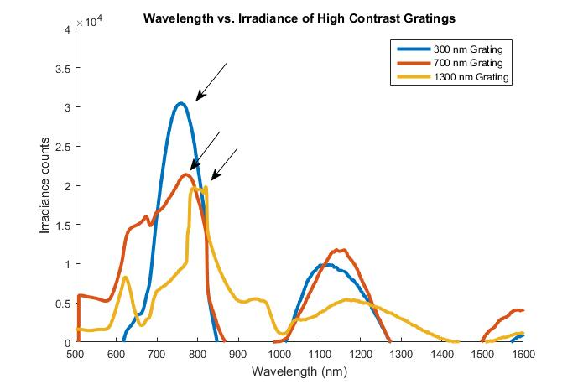
Fig. 2. Wavelength vs. Irradiance of the difference between measurements on the HCGs and a measurement of the Si₃N₄ wafer
TABLE I
WAVELENGTHS CORRESPONDING WITH THE MAXIMA IRRADIANCE FOUND FOR EACH GRATING
HCGs Pitch (nm) | Guided Wavelength (nm)
300 | 755
400 | 761
500 | 767
600 | 768
700 | 772
800 | 780
900 | 792
1000 | 772
1100 | 784
1200 | 788
1300 | 804

Resources
- W. Fang, Y. Huang, X. Duan, K. Liu, J. Fei, and X. Ren, “High-reflectivity high-contrast grating focusing reflector on silicon-on-insulator wafer,” Chinese Phys. B, vol. 25, no. 11, p. 114213, 2016.
- A. Polman and H. A. Atwater, “Photonic design principles for ultrahigh-efficiency photovoltaics,” Nat. Mater., vol. 11, no. 3, pp. 174–177, Feb. 2012.
- J. J. Low, M. L. Kreider, D. P. Pulsifer, A. S. Jones, and T. H. Gilani, “Band Gap Energy in Silicon,” Am. J. Undergrad. Res., vol. 7, no. 1, 2008.

