Homework #6
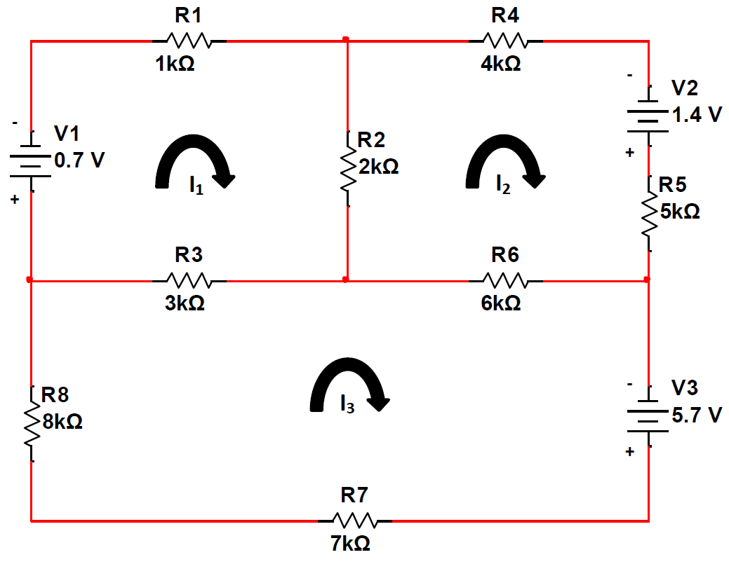
- Find I₁, I₂, and I₃.
- Find the voltage across R₁, R₂, and R₃.0

